|  |  |
| --- | --- |
| Course Code and Title: **23EEEC303/ Automotive Electronics** | |
| **UNIT II:** | Planned Hours: **4 hrs** |

|  |  |  |
| --- | --- | --- |
|  | 1 | Discuss the physical mechanism of wheel lock and vehicle skid that can occur during braking; How the ABS configuration provides a solution for this.  If the vehicle longitudinal acceleration is zero,  i) Calculate the wheel slip if vehicle speed is matching with wheel speed?  ii)Calculate wheel slip for Fl(Front left) and Fr(Front right), when vehicle speed is 70kph and WssFl(Wheel speed front left) and WssFr(Wheel speed front right) are reading 58 kph and 68 kph respectively  iii) Calculate wheel slip when panic braking is done at 150kph and ABS is shut down due to pump failure? |
|  | 2 | Answer the following with respect to FlexRay communication protocol.   1. Bus Level 2. Bus Guardian   Communication Cycle |
|  | 3 | What is ride and handling of an automobile? How electronic suspension system manages the compromise between ride comfort and handling? |
|  | 4 | Compare event driven and time triggered communication strategies. Calculate nominal and maximum THeader , TResponse and TFrame, if LIN is operating at 10 Kbps baud rate and reserved time is set to 30% for transmitting four bytes of data. |
|  | 5 | Answer the following with respect to CAN communication  i) The CAN node receives the message as 1011110, state whether the received information is error free or not. Assume CRC with a generator polynomial as 1011.  ii) How small nodes can be kept from overloading with received messages  iii) Message prioritization in case of CAN protocol.  iv) Draw the message sequence seen by the CAN bus for the given scenario.  C:\Users\giree\Desktop\New Microsoft PowerPoint Presentation21.jpg |
|  | 6 | The fast moving car is turning at the corner, if the vehicle is turning less/more than the driver’s intention suggest a suitable control system along with the break circuit configuration to overcome this condition |
|  | 7 | Assume that the driver has activated the cruise control switch set for the desired speed of (say, 60 mph). For the following conditions determine the action of throttle controlled by the suitable control algorithm;  i) If the car is travelling on a level road  ii) If the car is then to enter a long hill with a steady positive slope (i.e. a hill going up). |
|  | 8 | What is ride and handling of an automobile? Provide an electronic solution managing these conditions. |
|  | 9 | Describe the physical reasons why a car could skid or experience wheel lock when braking. Also, discuss the best wheel lock prevention control method.  i) Calculate the wheel slip if vehicle speed is matching with  wheel speed?  ii)Calculate wheel slip for Fl(Front left) and Fr(Front right), for which the wheel rpm is measured as 2000 rpm and 2200 rpm with wheel radius as 0.3 m, when vehicle speed is 68 kph.  iii) Calculate wheel slip when panic braking is done at 150kph and ABS is shut down due to pump failure? |
|  | 10 | What are the individual channels of MOST and what kind of information is transported therein? What is the coding technique used in MOST Physical layer? Determine how the data 10100111001 is transmitted. |
|  | 11 | Assume that the driver has activated the cruise control switch set for the desired speed of (say, 60 mph). For the following conditions, determine the action of throttle controlled by the suitable control algorithm;  i) If the car is travelling on a level road  ii) If the car is then to enter a long hill with a steady positive slope (i.e. a hill going up). |
|  | 12 | For the Communication schedule shown below, draw the  i) FlexRay cluster and  ii) Respective communication cycle. |
|  | 13 | Compare the two communication strategies, event-driven and time-triggered. Explain to the scenario how Flexray combines these two techniques into a single protocol. |
|  | 14 | Calculate nominal and maximum T Header, T Response, and T Frame, if LIN is operating at 10 Kbps baud rate and reserved time is set to 30% for transmitting four bytes of data. |
|  | 15 | Answer the following with respect to CAN communication  i)Difference between classical CAN and CAN FD  ii)Message prioritization in case of CAN protocol  iii)What solution CAN protocol offers for Long NRZ messages  iv) Propose the acceptance filter for a CAN controller to receive messages with IDs  0x441, 0x445 0x451, 0x455, 0x541,0x545,0x551, and 0x551 |
|  | 16 | What do you mean by over steering and under steering, with the necessary flow diagram how electronic stability program (ESP) counteracts the over steering and understanding condition? |
|  | 17 | With the necessary speed response plots discuss the role of for PI controllers for cruise control system. |
|  | 18 | Discuss the physical mechanism of wheel lock and vehicle skid that can occur during braking; how the ABS configuration provides a solution for this. Calculate the slip in percentage if the car is travelling at the speed of 60mph, with a wheel radius of 16 inches and if the wheel speed sensor is reading 2000 rpm |
|  | 19 | How can you improve the efficiency/performance /reliability of engine control unit by adding any extra sensors for the existing system? Mention the significance of sensors and related variables to be measured for engine control system. |
|  | 20 | What solution CAN protocol offers for long NRZ messages? What are the limitations of that solution? |
|  | 21 | The CAN node has to transmit the message 11101, show how this message is transmitted, and explain how the CAN receiver node determines whether the message is error free or not. (Assume CRC of CAN uses (7,4) CRC with the generator polynomial as 1011). |
|  | 22 | Explain the difference between active and passive safety system. |
|  | 23 | Why traction control is necessary in automobiles? Suggest an electronic solution of Driving Dynamic control system. |
|  | 24 | Describe the working of Electronic suspension system, Electronic power steering systems. |
|  | 25 | Imagine you are travelling on a modern vehicle, stopped the vehicle at the signal and switched to neutral gear, but co-travelers insisted to switch on the AC but vehicle is at idle rpm of 800, will this rpm be sufficient to drive the demanded load, if not how is handled by the e engine management system. |
|  | 26 | How performance is enhanced for TCS with an additional sensor input along with conventional wheel speed sensor input. Justify your answer the representative block diagram. |

**1. Discuss the physical mechanism of wheel lock and vehicle skid that can occur during braking; How the ABS configuration provides a solution for this.**

**If the vehicle longitudinal acceleration is zero,**

**i) Calculate the wheel slip if vehicle speed is matching with wheel speed?**

**ii)Calculate wheel slip for Fl(Front left) and Fr(Front right), when vehicle speed is 70kph and WssFl(Wheel speed front left) and WssFr(Wheel speed front right) are reading 58 kph and 68 kph respectively**

**iii)Calculate wheel slip when panic braking is done at 150kph and ABS is shut down due to pump failure?**

Wheel Lock and Vehicle Skid During Braking

* **Wheel Lock**: Happens when brakes stop wheels from rotating while the car is still moving.
* **Vehicle Skid**: Occurs when tires lose grip on the road, often due to locked wheels.

**ABS (Anti-lock Braking System)**

* **Prevents Wheel Lock**: Modulates brake pressure to keep wheels rotating.
* **Key Components**:
  + **Wheel Speed Sensors**: Monitor each wheel's speed.
  + **Control Module**: Processes speed data to detect potential lockup.
  + **Hydraulic Modulator**: Adjusts brake pressure to maintain traction.

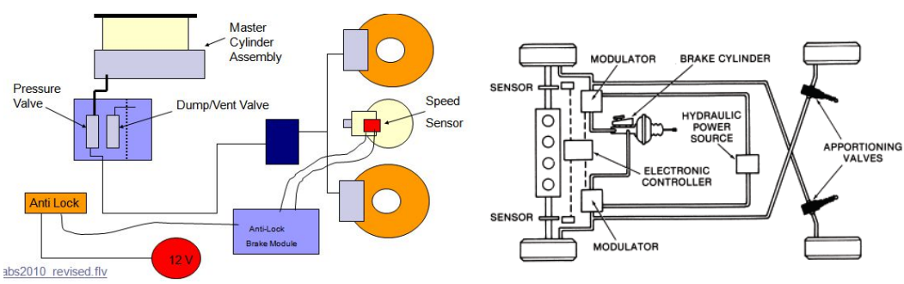

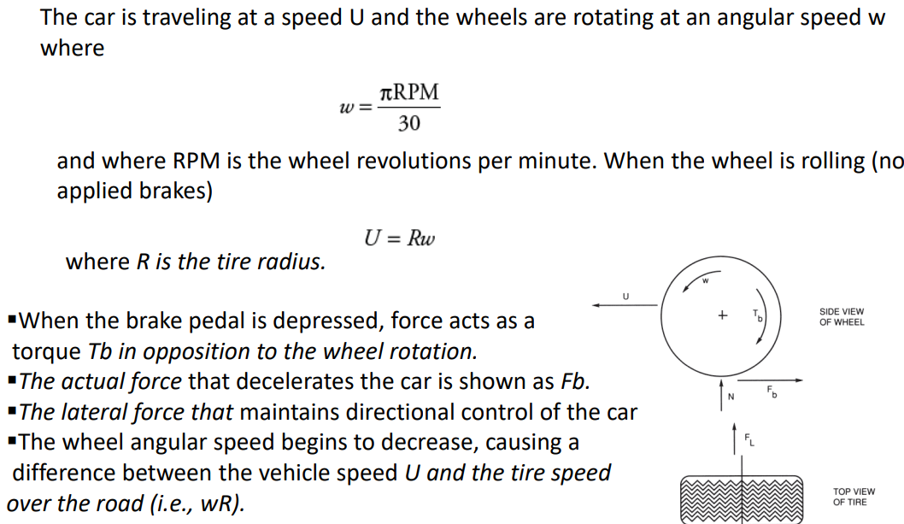

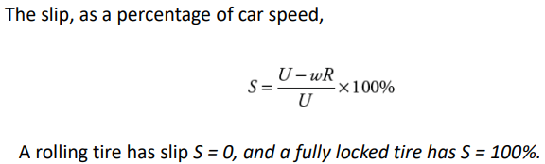

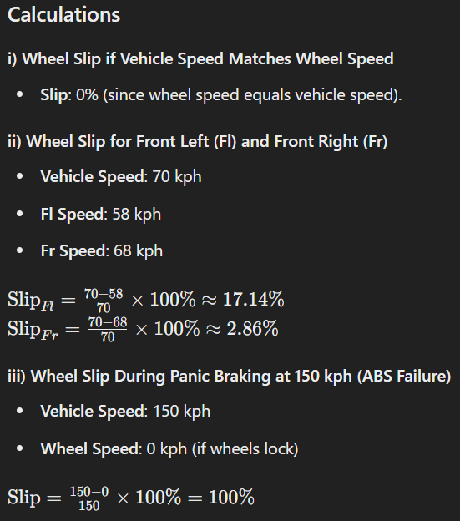

**Summary**

* **Wheel Lock**: Stops wheel rotation, causing loss of traction.
* **Vehicle Skid**: Loss of friction, causing loss of control.
* **ABS**: Prevents wheel lock by adjusting brake pressure, maintaining control.
* **Wheel Slip Calculations**:
  + **0%** if speeds match.
  + **17.14%** for Fl (58 kph) and **2.86%** for Fr (68 kph).
  + **100%** during panic braking at 150 kph with ABS failure.

3)What is ride and handling of an automobile? How electronic suspension system manages the compromise between ride comfort and handling?

**🡺The terms "ride" and "handling" are key aspects of an automobile's performance, particularly in how it interacts with the road and responds to driver inputs.**

**Ride and Handling of an Automobile**

* **Ride**: This refers to how smooth the car feels when driving over bumps or rough roads. A good ride means passengers feel minimal jolts or vibrations.
* **Handling**: This refers to how well the car responds to actions like turning or braking. Good handling means the car is stable and responds quickly to the driver's inputs.

**How Electronic Suspension System Manages the Compromise**

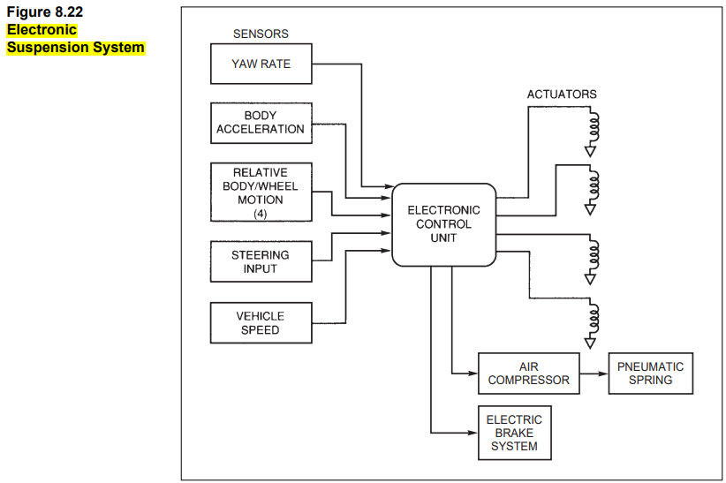

The electronic suspension system helps balance ride comfort and handling by:

* **Variable Damping**: Unlike traditional suspensions with fixed settings, electronic suspensions can adjust their firmness. This means they can be softer on bumpy roads for comfort and firmer during turns for better handling.
* **Active and Semi-Active Systems**:
  + **Semi-Active Systems**: These adjust the shock absorbers to reduce the impact of wheel movements based on road conditions.
  + **Active Systems**: These add extra power to the suspension to maintain the best ride quality without losing good handling.

In short, electronic suspension systems adapt to different driving situations to provide a smooth ride and stable handling.

4) Compare event driven and time triggered communication strategies.

Calculate nominal and maximum THeader , TResponse and TFrame, if LIN is operating at 10 Kbps baud rate and reserved time is set to 30% for transmitting four bytes of data.

**Comparison of Event-Driven vs. Time-Triggered Communication**

| **Aspect** | **Event-Driven Communication** | **Time-Triggered Communication** |
| --- | --- | --- |
| **Triggering** | Based on events or actions | Based on a fixed schedule |
| **Synchronization** | Syncs with sender | Syncs with a global clock |
| **Bus Access** | Accesses bus anytime, uses priorities | Accesses bus in fixed time slots |
| **Priority** | Priorities determine order of messages | Schedule determines message order |
| **Performance** | Flexible, efficient with sporadic events | Consistent, ideal for safety-critical tasks |
| **Complexity** | Simpler, but unpredictable latency | More complex, precise timing |
| **Latency** | Variable, lower priority may delay | Fixed, predictable timing |
| **Determinism** | Less predictable | Highly predictable |
| **Efficiency** | Efficient with low message frequency | Can be inefficient with idle slots |
| **Fault Tolerance** | Less fault-tolerant, risk of collisions | Higher fault tolerance, redundancy built-in |
| **Suitability** | Non-critical, less timing-sensitive applications | Real-time, safety-critical applications |

Event-driven systems are flexible and simple, ideal for less critical tasks. Time-triggered systems offer predictability and reliability, making them suitable for crucial applications requiring strict timing.

**Given:**

* Baud rate: 10 Kbps (10,000 bits per second)
* Reserved time: 30%
* Data to be transmitted: 4 bytes (32 bits)

**Calculations**

**1. Bit Time**

Bit time(𝑇bit)=1/Baud rate=1/10,000 bits/second=100 µs

**2. Nominal Times**

**THeader**

* **Break field**: 13 bits Break field time=13×100 µs=1300 µs
* **Sync field**: 8 bits (1 byte) Sync field time=8×100 µs=800 µs
* **Identifier field**: 8 bits (1 byte)

Identifier field time=8×100 µs=800 µs

Nominal THeader=1300 µs+800 µs+800 µs=2900 µs

**TResponse**

* **Data field**: 4 bytes (32 bits)

Data field time=32×100 µs=3200 µs

* **Checksum field**: 8 bits (1 byte)

Checksum field time=8×100 µs=800 µs

Nominal TResponse=3200 µs+800 µs=4000 µs

**TFrame**

Nominal TFrame=Nominal THeader+Nominal TResponse Nominal TFrame=2900 µs+4000 µs=6900 µs

**3. Consider Reserved Time (30%)**

Reserved time=30%

Maximum TFrame=Nominal TFrame/(1−Reserved time)

Maximum TFrame=6900 µs/(1−0.30)

Maximum TFrame=6900 µs/0.70

Maximum TFrame≈9857 µs

**4. Maximum THeader and TResponse**

To distribute the reserved time proportionally:

**THeader (max)**

Maximum THeader=Nominal THeader/(1−Reserved time)​

Maximum THeader=2900 µs/(1−0.30)

Maximum THeader=2900 µs/0.70

Maximum THeader≈4143 µs

**TResponse (max)**

Maximum TResponse=Nominal TResponse/(1−Reserved time)​ Maximum TResponse=4000 µs/(1−0.30)​

Maximum TResponse=4000 µs/0.70​

Maximum TResponse≈5714 µs

**Summary**

* **Nominal THeader**: 2900 µs
* **Nominal TResponse**: 4000 µs
* **Nominal TFrame**: 6900 µs
* **Maximum THeader**: 4143 µs
* **Maximum TResponse**: 5714 µs
* **Maximum TFrame**: 9857 µs

This calculation shows the nominal and maximum times for THeader, TResponse, and TFrame for a LIN operating at 10 Kbps with a 30% reserved time.

**5) Answer the following with respect to CAN communication**

**i) The CAN node receives the message as 1011110, state whether the received information is error free or not. Assume CRC with a generator polynomial as 1011.**

**ii) How small nodes can be kept from overloading with received messages**

**iii) Message prioritization in case of CAN protocol.**

**iv) Draw the message sequence seen by the CAN bus for the given** **scenario**.

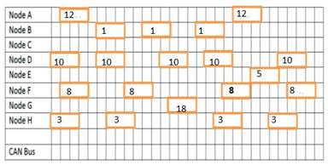

**i) Error Checking Using CRC**

* **Received message**: **1011110**
* **Generator polynomial**: **1011**
* **Calculation**: Append 3 zeros to the message (since the polynomial length is 4), perform binary division, and check the remainder.
* **Result**: The remainder is **1001** (not zero), so the message is **not error-free**.

**ii) Preventing Small Nodes Overloading**

* **Message Filtering**: Nodes process only relevant messages based on their IDs.
* **Acceptance Filtering**: CAN controllers ignore irrelevant messages.
* **Buffer Management**: Use buffers to manage bursts of messages.

**iii) Message Prioritization in CAN**

* **Arbitration Field**: Lower numerical IDs have higher priority.
* **Non-Destructive Arbitration**: The node with the lowest ID wins bus access without losing control.

**iv) Message Sequence on CAN Bus**

Based on the given image:

* **Sequence**:
  1. Node B (ID **1**)
  2. Node H (ID **3**)
  3. Node E (ID **5**)
  4. Node F (ID **8**)
  5. Node D (ID **10**)
  6. Node A (ID **12**)
  7. Node G (ID **18**)
* **Reason**: Lower ID messages are sent first due to higher priority.

**6) The fast moving car is turning at the corner, if the vehicle is turning less/more than the driver’s intention suggest a suitable control system along with the break circuit configuration to overcome this condition**

When a fast-moving car doesn't turn as intended at a corner, the **Electronic Stability Program (ESP)** helps correct this. Here's how it works and the brake system it uses:

**ESP (Electronic Stability Program)**

**Components:**

* **Wheel Speed Sensors:** Monitor each wheel's speed.
* **Steering Angle Sensor:** Detects which way the steering wheel is turned.
* **Yaw Rate Sensor:** Measures how much the car is rotating.
* **Lateral Acceleration Sensor:** Senses side-to-side movement.
* **Longitudinal Acceleration Sensor:** Measures forward and backward acceleration.

**Brake System:**

* **Integrated with ABS and TCS:** ESP works with the Anti-lock Braking System (ABS) and Traction Control System (TCS).
* **Solenoid Valves:** These control brake pressure for each wheel individually.
* **Pressure Regulation:** Adjusts brake pressure on each wheel to keep the car stable.

**How It Works:**

1. **Sensors Monitor Motion:** They check if the car is moving as intended.
2. **Calculate Correction:** If the car is turning too much or too little, ESP decides how much brake force to apply to each wheel.
3. **Apply Brakes:** ESP automatically applies the brakes to individual wheels to correct the car’s path.

**Benefits:**

* **Maintains Control:** Helps keep the car on the intended path during sharp turns.
* **Prevents Skidding:** Reduces the chance of losing control.
* **Enhances Safety:** Works with ABS and TCS for better overall vehicle stability.

**Summary:**

ESP helps keep your car on the right path by using sensors to monitor its motion and applying brakes to individual wheels when needed. This system ensures the car turns as intended, especially during fast or sharp maneuvers.

**7)Assume that the driver has activated the cruise control switch set for the desired speed of (say, 60 mph). For the following conditions determine the action of throttle controlled by the suitable control algorithm;**

**i) If the car is travelling on a level road**

**ii) If the car is then to enter a long hill with a steady positive slope (i.e. a hill going up).**

🡺i) **On a Level Road:** When cruising on a flat road at 60 mph, the cruise control system maintains this speed by adjusting the throttle as needed. If the car starts to slow down below 60 mph, it adds more gas to speed up. Conversely, if it starts to go too fast, it eases off the gas to slow down. This process ensures a steady speed without the driver needing to adjust the throttle manually.

ii) **Entering a Hill with a Positive Slope:** As the car encounters an uphill slope, it naturally slows down due to gravity. To counteract this and maintain the set speed of 60 mph, the cruise control system increases the throttle, giving more power to the engine. It continuously monitors the speed and adjusts the throttle as necessary to prevent the car from dropping below 60 mph. If the hill gets steeper, the system might increase throttle even more to compensate, ensuring a smooth ascent while keeping to the desired speed.

In both situations, there's a smart system called a PID(Proportional-Integral-Derivative) controller that's like the car's brain. It constantly checks if we're going at the right speed (60 mph) and if not, it figures out how much gas to give to get us back to that speed. It's like having a co-pilot who's always making small adjustments to keep the ride smooth and steady, without going too fast or too slow.

8) What is ride and handling of an automobile? Provide an electronic solution managing these conditions.

- **Ride:** It's how smoothly your car moves over bumps. A good ride means the car body stays calm, not bouncing all over the place.

- **Handling:** Handling is about how well your car responds when you steer or brake suddenly. Good handling means it stays steady and in control.

- **Electronic Solution:** Electronic Suspension Systems help with both ride and handling. They use sensors and a computer to adjust how stiff or soft your car's shocks are. This keeps the ride comfy on bumpy roads but also helps with sharp turns or sudden stops. There are two types: Semi-Active, which balances comfort and control, and Active, which goes further to make the ride super smooth and the handling sharp. They make driving safer and more comfortable by adapting to different road conditions automatically.

10) What are the individual channels of MOST and what kind of information is transported therein? What is the coding technique used in MOST Physical layer? Determine how the data 10100111001 is transmitted.

* **MOST Channels:**
  + **Synchronous Channel:** Streams audio and video data that need constant rates for real-time transmission.
  + **Asynchronous Channel:** Handles bursty packet data like file transfers or system updates.
  + **Control Channel:** Sends control commands and status info between devices in the network.
* **Coding Technique in MOST Physical Layer:**
  + MOST uses **Non-Return to Zero Inverted (NRZI)** signaling. Here, '1' is represented by no change in the signal, and '0' is represented by a change.
* **Data Transmission in MOST:**
  + For the data sequence **10100111001**, using NRZI coding, it starts with a change for the first '1', no change for the following '0', change for the next '1', and so on.
  + The actual physical signal depends on the initial state, but subsequent changes follow the data sequence, with '0's causing a change and '1's causing no change.

This coding keeps the transmitter and receiver clocks in sync by frequently changing the signal. It strikes a balance between signal integrity and complexity, ideal for automotive applications.